Architecture Document Outline: AI-Driven Fraud Detection for Black Friday 2025
Scenario: During Black Friday 2025, a global e-commerce marketplace anticipates a 400% transaction spike (50M payments/hour). Fraud (account takeovers, synthetic identities, false chargebacks) is projected to increase by 3.5x. The BFSI partner bank requires real-time fraud detection with <250ms transaction approval latency.
Problem Statement: How can AI-driven fraud detection and automation of dispute resolution workflows be architected to ensure real-time risk mitigation without degrading customer experience during peak load?

1. Introduction & Business Challenge
- 1.1. Executive Summary:
  - Briefly state the critical challenge: managing a massive surge in transactions and sophisticated fraud during Black Friday 2025 while maintaining real-time performance and customer trust.
  - Highlight the proposed AI-driven and automated solution to meet these demands.
- 1.2. Business Challenge and Context:
  - Black Friday 2025 Impact: Detail the anticipated 400% transaction spike (50 million payment requests/hour) and the 3.5x increase in fraudulent activities (account takeovers, synthetic identities, false chargebacks).
  - BFSI Partner Bank's Mandate: Emphasize the dual objective:
    - Ensure real-time fraud detection.
    - Maintain transaction approval latency under 250ms.
  - Current Limitations (Assumed): Briefly touch upon why existing manual or rule-based systems would fail under this load (e.g., scalability issues, high false positives/negatives, slow dispute resolution).
  - Strategic Importance: Explain how a successful solution safeguards revenue, reputation, and customer loyalty.

2. Functional & Non-Functional Requirements (NFRs, Metrics & KPIs)
- 2.1. Functional Requirements:
  - F.1. Real-time Fraud Detection:
    - Detect account takeovers (ATO), synthetic identities, and false chargeback patterns in real-time.
    - Identify known fraudster patterns and emerging anomalies.
  - F.2. Transaction Scoring & Decisioning:
    - Generate a real-time fraud risk score for each transaction.
    - Support automated Approve/Decline/Review decisions based on risk scores and configurable thresholds.
  - F.3. Automated Dispute Resolution Workflow Initiation:
    - Automatically trigger dispute resolution workflows for flagged transactions, gathering relevant data (transaction details, customer history, fraud indicators).
    - Categorize disputes for efficient handling (e.g., low-value auto-resolution vs. high-value human review).
  - F.4. Integration with Core Banking & Payment Systems:
    - Seamlessly integrate with payment gateways, core banking systems, customer information systems, and external fraud databases.
  - F.5. Case Management & Reporting:
    - Provide a robust case management interface for fraud analysts to review and manage flagged transactions.
    - Generate comprehensive reports and dashboards on fraud trends, system performance, and dispute resolution status.
- 2.2. Non-Functional Requirements (NFRs):
  - NFR.1. Performance (ISO/IEC 25010: Performance Efficiency):
    - Latency: Average transaction approval latency < 250ms during peak load.
    - Scalability: Process 50 million payment requests/hour, with dynamic scaling to handle peak loads (400% spike).
    - Throughput: Support sustained transaction rates without degradation.
  - NFR.2. Reliability & Availability (ISO/IEC 25010: Reliability):
    - Availability: System uptime > 99.99% during Black Friday period.
    - Resilience: Graceful degradation and fault tolerance; automatic failover mechanisms.
  - NFR.3. Security (ISO/IEC 25010: Security):
    - Data Protection: End-to-end encryption for sensitive financial data (in transit and at rest).
    - Access Control: Role-based access control (RBAC) for all system components.
    - Compliance: Adherence to PCI DSS, GDPR, AML, and other relevant financial regulations.
  - NFR.4. Maintainability (ISO/IEC 25010: Maintainability):
    - Modularity: Loosely coupled components for independent deployment and scaling.
    - Manageability: Easy monitoring, logging, and troubleshooting capabilities.
  - NFR.5. Usability (ISO/IEC 25010: Usability):
    - Intuitive user interface for fraud analysts and operations teams.
  - NFR.6. Explainability (NIST AI RMF: Govern):
    - Model Interpretability: AI model decisions must be explainable, providing reasons for fraud flags to aid human analysts and regulatory compliance.
- 2.3. Metrics & KPIs:
  - Fraud Detection Effectiveness:
    - Fraud Detection Rate (True Positives / Total Fraud).
    - False Positive Rate (FPR): (False Positives / Total Legitimate Transactions).
    - False Negative Rate (FNR): (False Negatives / Total Fraud).
    - Precision, Recall, F1-Score for fraud models.
  - Operational Efficiency:
    - Average transaction approval latency.
    - Automated dispute resolution rate (percentage of disputes handled without manual intervention).
    - Time to resolution for automated vs. manual disputes.
    - Cost per detected fraud.
  - System Performance:
    - System uptime and availability.
    - API response times.
    - Resource utilization (CPU, memory, network).
  - Customer Experience:
    - Customer friction score (e.g., number of legitimate transactions falsely declined).

3. Proposed Architecture Building Blocks and Interactions
The architecture leverages a microservices-based approach with real-time data streaming, AI/ML models, and workflow automation.
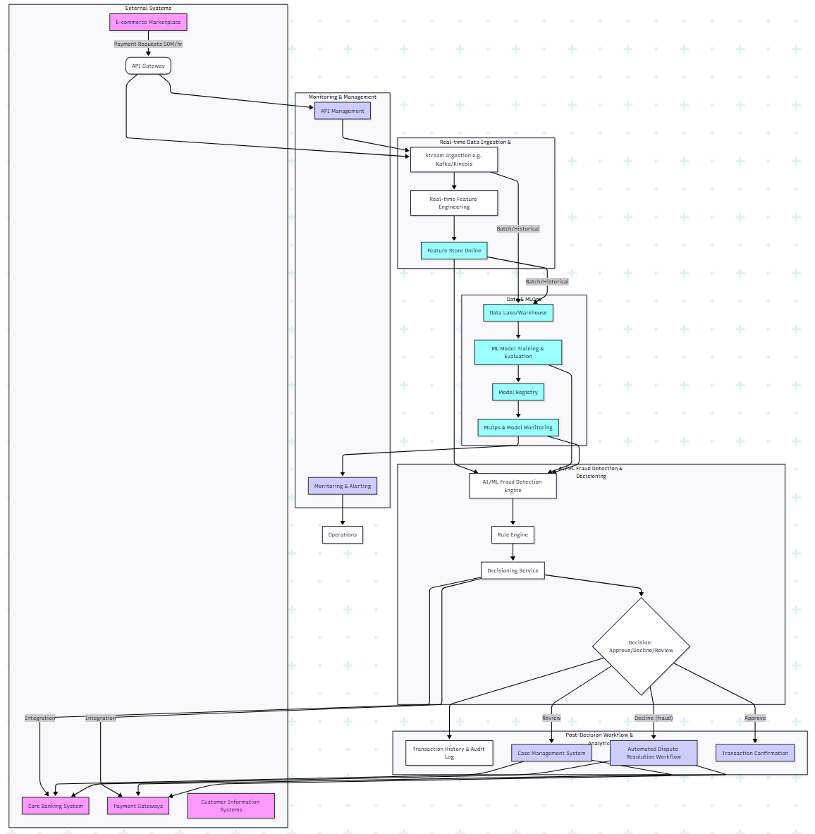
- 3.1. Building Blocks:
  - API Gateway: Ingress point for all transaction requests, handles rate limiting, authentication, and initial routing.
  - Stream Ingestion (e.g., Apache Kafka, AWS Kinesis): High-throughput, low-latency messaging backbone for ingesting raw transaction data.
  - Real-time Feature Engineering Service: Processes raw stream data to derive features (e.g., velocity features, historical aggregates, behavioral patterns) required by ML models.
  - Feature Store (Online/Offline):
    - Online Feature Store: Serves real-time features to ML models at ultra-low latency.
    - Offline Feature Store: Used for batch feature generation for model training and historical analysis.
  - AI/ML Fraud Detection Engine:
    - Model Inference Service: Hosts pre-trained ML models (e.g., XGBoost, Isolation Forests, Deep Learning for anomalies, Graph Neural Networks for linked entities) to score transactions in real-time.
    - Explainable AI (XAI) Component: Provides interpretability for model decisions (e.g., SHAP values, LIME).
  - Rule Engine: Executes a set of pre-defined, deterministic fraud rules (e.g., block transactions from sanctioned countries, high-value threshold alerts). Acts as a first layer or complement to ML.
  - Decisioning Service: Orchestrates the fraud detection process. It takes inputs from the Rule Engine and AI/ML Engine, applies business logic, and makes a final Approve/Decline/Review decision based on aggregate risk scores and thresholds.
  - Transaction History & Audit Log: Stores all transaction details, fraud scores, and decision outcomes for auditing, analysis, and compliance.
  - Automated Dispute Resolution Workflow: Orchestrates the initial steps of dispute resolution for flagged fraudulent transactions. This can include freezing funds, notifying relevant parties, and gathering initial evidence.
  - Case Management System: A dedicated system for human fraud analysts to review high-risk transactions or complex disputes that require manual intervention.
  - Data Lake/Warehouse: Centralized repository for all raw and processed data, essential for historical analysis, model retraining, and reporting.
  - MLOps & Model Monitoring: Tools and processes for continuous integration/continuous deployment (CI/CD) of ML models, monitoring model performance (drift detection), and automated retraining.
  - Monitoring & Alerting: Comprehensive dashboards and alert systems for system health, performance, and fraud metrics.
- 3.2. Interactions:
  - External payment requests flow through the API Gateway to the Stream Ingestion layer.
  - Data is processed in real-time, features are engineered and stored in the Feature Store.
  - The Decisioning Service queries the Rule Engine and AI/ML Fraud Detection Engine, which retrieves features from the Feature Store.
  - Based on the combined output, a decision is made (Approve, Decline, Review).
  - Approved transactions proceed; declined transactions trigger automated dispute workflows; reviewed transactions go to the Case Management System.
  - All decisions and data are logged. MLOps continuously monitors and updates models based on data from the Data Lake/Warehouse.

4. AI & Automation Augmentation
- 4.1. AI Augmentation:
  - Real-time Fraud Detection:
    - Anomaly Detection: AI models (e.g., Isolation Forests, Autoencoders, Deep Learning) identify transactions deviating from normal patterns, crucial for detecting emerging fraud types (e.g., synthetic identities, new ATO vectors).
    - Behavioral Biometrics: Machine Learning models analyze user behavior (e.g., login patterns, transaction frequency, device information) to establish baselines and flag suspicious deviations indicative of account takeovers.
    - Graph Neural Networks (GNNs): Analyze relationships between entities (customers, devices, merchants) to uncover sophisticated fraud rings and synthetic identities.
    - Predictive Scoring: Assigning a continuous fraud risk score to each transaction, allowing for nuanced decision-making beyond binary rules.
  - Predictive Analytics: AI models analyze historical data and current trends to forecast future fraud risks, identify new fraud typologies, and adapt detection strategies proactively.
  - Explainable AI (XAI): Provides transparency into why a transaction was flagged, supporting human analysts and regulatory compliance, ensuring "explainability & traceability" for AI decisions (Best Practice).
- 4.2. Automation Augmentation:
  - Automated Transaction Decisioning: High-confidence low-risk transactions are auto-approved, and high-confidence high-risk transactions are auto-declined, reducing manual review queues significantly.
  - Automated Dispute Resolution Initiation: For detected fraud, the system automatically creates a dispute case, gathers initial evidence (transaction logs, IP addresses, device IDs), and initiates communication with relevant parties (customer, merchant, payment processor). This automates "dispute resolution workflows."
  - Infrastructure Orchestration (e.g., Kubernetes): Automatically scales processing power and AI inference services up/down to handle the dynamic load fluctuations during Black Friday, ensuring "resilience-first" (Best Practice) and meeting NFRs.
  - MLOps Automation: Automates model retraining, deployment, and monitoring, ensuring models stay up-to-date with evolving fraud patterns (e.g., CI/CD pipelines for models, automated drift detection alerts).
  - Automated Reporting & Alerting: Real-time dashboards and automated alerts on key KPIs (fraud rates, latency, FPR/FNR) for operations and risk teams.

5. Risks, Compliance, and Trade-offs
- 5.1. Risks:
  - False Positives: Blocking legitimate customer transactions, leading to degraded customer experience, reputational damage, and lost revenue.
  - False Negatives: Failure to detect actual fraud, resulting in direct financial losses for the bank and marketplace.
  - Model Drift: AI models becoming less effective over time as fraud patterns evolve, requiring continuous monitoring and retraining.
  - Data Quality & Availability: Poor data quality or insufficient real-time data feeds can severely impair AI model performance.
  - System Latency: Inability to meet the <250ms NFR under extreme peak load, impacting transaction processing.
  - Regulatory Scrutiny: Lack of explainability or bias in AI models can lead to compliance issues and legal challenges.
  - Integration Complexity: Integrating with numerous legacy BFSI systems can be complex and time-consuming.
  - AI Bias: Unintended bias in training data leading to discriminatory fraud detection for certain customer segments.
- 5.2. Compliance:
  - NIST AI Risk Management Framework (RMF): Applied to ensure trustworthy AI (governance, mapping, measuring, managing AI risks related to bias, privacy, security, and explainability).
  - ISO/IEC 25010: Utilized for defining and measuring software quality attributes, particularly for NFRs.
  - GDPR/CCPA & Data Privacy: Strict adherence to data privacy regulations regarding customer financial and behavioral data.
  - PCI DSS: Compliance for handling credit card information.
  - AML (Anti-Money Laundering): Ensuring the system aids in identifying and reporting suspicious transactions.
  - Explainability Requirements: Meeting regulatory demands for transparency in automated decision-making.
- 5.3. Trade-offs:
  - Accuracy vs. Latency: More complex AI models might offer higher accuracy but could increase inference latency. A balance must be struck (e.g., using simpler, faster models for initial screening, more complex for secondary review).
  - Automation vs. Human Intervention: Fully automating dispute resolution for all fraud types may introduce higher risk. Define clear boundaries where manual review is mandatory ("Always document AI/automation boundaries" Best Practice).
  - Cost vs. Performance/Resilience: Building highly scalable, highly available, and resilient real-time systems requires significant investment in infrastructure and specialized personnel.
  - Explainability vs. Model Complexity: Highly accurate "black-box" models (e.g., deep neural networks) might be less explainable than simpler models (e.g., decision trees). Prioritize explainability given the BFSI context.
  - False Positives vs. False Negatives: Tuning fraud thresholds involves a trade-off. Lowering false negatives (catching more fraud) often increases false positives (blocking more legitimate customers), and vice-versa. Optimal balance depends on risk appetite.

6. Architecture Decision Records (ADRs)
ADRs will be used rigorously to document significant architectural decisions, their context, options considered, the chosen option, and the consequences. This ensures "traceability of design choices" and "ADR rigor to justify automation vs. manual interventions" (Best Practices).
- Example ADRs for this scenario:
  - ADR-001: Real-time Streaming Technology Selection:
    - Context: Need for high-throughput, low-latency data ingestion for 50M transactions/hour.
    - Options: Apache Kafka, AWS Kinesis, Google Pub/Sub.
    - Decision: Apache Kafka (self-managed or confluent cloud) for its ecosystem, scalability, and battle-tested performance in similar use cases.
    - Consequences: Requires operational expertise, but offers maximum control and flexibility.
  - ADR-002: Primary AI Fraud Detection Model:
    - Context: Need for a highly accurate, low-latency model to identify diverse fraud types.
    - Options: XGBoost, LightGBM, Deep Learning (e.g., DNN, GNN).
    - Decision: Hybrid approach - XGBoost for initial scoring due to speed and explainability; GNN for identifying sophisticated fraud rings within the Case Management review process.
    - Consequences: Balances latency with detection capability; requires integration of multiple models.
  - ADR-003: Threshold for Automated Dispute Resolution:
    - Context: Define criteria for automatically initiating dispute workflows vs. manual review.
    - Options: Value-based (e.g., <$50 auto-resolve), Confidence-score based (e.g., ML score > 0.95 auto-resolve), Type-of-fraud based (e.g., known synthetic identity auto-resolve).
    - Decision: Combine confidence score and transaction value. Transactions with ML fraud score > X AND value < Y are auto-resolved. Others proceed to human review or a more complex automated flow.
    - Consequences: Reduces manual workload but carries inherent risk of misclassification for auto-resolved cases. Requires continuous monitoring and adjustment.
  - ADR-004: Cloud Provider Selection for Scalability:
    - Context: Need for elastic scalability to handle 400% transaction spike.
    - Options: AWS, Azure, Google Cloud.
    - Decision: (e.g., AWS) due to existing organizational expertise, mature managed services (Kinesis, SageMaker, ECS/EKS), and global reach.
    - Consequences: Potential vendor lock-in, reliance on AWS pricing models.

Best Practices & Frameworks Discussion
- Arc42: This document structure itself adheres to Arc42, providing a comprehensive and standardized view of the architecture.
- TOGAF ADM: The process of defining business challenges, requirements, and an architecture vision aligns with the preliminary and architecture vision phases of TOGAF ADM.
- ISO/IEC 25010: Explicitly used for documenting and categorizing non-functional requirements.
- NIST AI RMF: Integrated into the risks and compliance section, ensuring considerations for trustworthy AI, fairness, accountability, and transparency.
- MLOps Frameworks: The inclusion of an MLOps component in the architecture (model training, deployment, monitoring, drift detection) demonstrates adherence to operationalizing AI.
- AI/Automation Boundaries: Clearly defined in the "Automation Augmentation" section and through ADRs (e.g., automated vs. manual dispute resolution thresholds).
- Metrics-Driven Design: Integrated throughout NFRs and KPIs, emphasizing latency, accuracy, and efficiency.
- Explainability & Traceability: A core NFR and part of the AI augmentation, critical for BFSI.
- Resilience-First: Addressed through scalable infrastructure (Kubernetes), fault tolerance, and automated fallbacks.
- ADR Rigor: Advocated for documenting all critical decisions and their rationale.

